EXPERIMENT - 11
CREATING A SIMPLE PROFESSIONAL
PROFILE PAGE ON LINKEDIN
AIM
To understand the importance of a professional online presence and
create a simple, complete, and professional LinkedIn profile that
highlights academic qualifications, technical skills, projects, and
interests related to Artificial Intelligence and its Applications.

OBJECTIVE
To understand the importance of LinkedIn as a professional
networking platform.
To create a professional online identity.
To present academic and technical information in an organized
manner.
To showcase AI-related skills, projects, certifications, and
achievements.
To understand how professional profiles can support career
opportunities in Artificial Intelligence and related fields.

INTRODUCTION
LinkedIn is a professional networking platform used by students,
educators, researchers, and industry professionals. It allows users to
create an online professional profile containing their education,
skills, projects, certifications, experience, and achievements.
For students studying Artificial Intelligence and its Applications,
LinkedIn can be used to showcase knowledge in areas such as
Artificial Intelligence, Machine Learning, Deep Learning, Python, Data
Analytics, Computer Vision, Natural Language Processing, and
Generative AI.A well-designed LinkedIn profile acts as a digital resume and helps
students connect with professionals, discover internships and job
opportunities, and build a professional network.

AI APPLICATION IN PROFESSIONAL PROFILE BUILDING
Artificial Intelligence can assist users in creating and improving
professional profiles. AI-based tools can help with:
Generating professional profile summaries.
Improving grammar and sentence structure.
Suggesting relevant technical skills.
Creating professional headlines.
Summarizing academic projects.
Generating suitable descriptions for internships and experiences.
Recommending keywords for better profile visibility.
Personalizing resumes and professional descriptions.
Thus, AI can be used as a supporting tool while creating a
professional digital identity.

TOOLS REQUIRED
Computer or smartphone
Internet connection
Web browser such as Google Chrome or Microsoft Edge
LinkedIn website or mobile application
Valid email ID or phone number
Professional photograph
Academic information
List of technical skills and projects
AI tool such as ChatGPT for preparing professional descriptions
(optional)

PROCEDURE
Step 1: Preparing the InformationBefore creating the LinkedIn profile, collect the required information
such as:
Full name
Current designation
College/institution name
Department
Location
Educational qualification
Technical skills
Projects
Certifications
Achievements
Areas of interest
For an AI student, relevant skills may include Python, Artificial
Intelligence, Machine Learning, Deep Learning, Data Analytics, and
Generative AI.
Step 2: Creating a LinkedIn Account
1. Open a web browser.
2. Visit the LinkedIn website.
3. Select Join Now.
4. Enter an email address or phone number.
5. Create a secure password.
6. Enter the required personal details.
7. Verify the account using the OTP or confirmation link.
Step 3: Adding Profile Photo and Background
1. Open the LinkedIn profile.
2. Select View Profile.
3. Click the profile photo area.
4. Upload a clear and professional photograph.
5. Add a suitable background/banner image.6. The banner may represent Artificial Intelligence, technology,
programming, or the student's academic field.
Step 4: Adding Name, Headline and Location
Enter the basic profile information.
Example Headline:
AI & Machine Learning Student | Python | Data Analytics | Interested
in Artificial Intelligence Applications
Add the city and country in the location field.
The headline should be short, professional, and relevant to the
student's career interests.
Step 5: Creating the About Section
The About section should provide a brief introduction about the
student's academic background, interests, skills, and career goals.
AI tools can be used to improve grammar and generate a
professional draft. However, the final content should be reviewed
and edited by the student to ensure that it is accurate.
Step 6: Adding Education Details
Add educational information including:
College/University name
Degree
Department/Field of study
Starting year
Expected graduation year
Relevant academic activities
For example:
Degree: Bachelor of Engineering
Branch: Electronics and Communication EngineeringArea of Interest: Artificial Intelligence and Machine Learning
Step 7: Adding Experience and Projects
Add internships, workshops, training, volunteering, or project
experience.
For students without work experience, academic projects can be
presented under the appropriate project or experience section.
Examples of AI-related projects include:
Machine Learning Model
CNN Image Classification
GAN Implementation
Smart Speaker AI Application
Data Analytics Project
AI-based Prediction System
Each project should contain a short description of the objective,
technologies used, and outcome.
Step 8: Adding Technical Skills
Add relevant technical and professional skills.
Example AI-related skills:
Artificial Intelligence
Machine Learning
Deep Learning
Python
Data Analytics
Natural Language Processing
Computer Vision
Generative AI
TensorFlow
PyTorch
Problem SolvingCommunication
Only skills that the student actually understands or has experience
with should be included.
Step 9: Reviewing the Profile
Review the complete profile before publishing.
Check:
Profile photo
Name
Headline
About section
Education
Experience/projects
Skills
Certifications
Contact information
Grammar and spelling
Privacy and visibility settings
AI writing tools may be used to proofread the profile, but factual
information must be verified manually.
Step 10: Publishing and Sharing
1. Open View Profile.
2. Check how the profile appears to other users.
3. Make corrections if required.
4. Copy the profile URL.
5. The profile link can be added to a resume, portfolio, email
signature, or academic application.

SAMPLE OUTPUT SCREEN

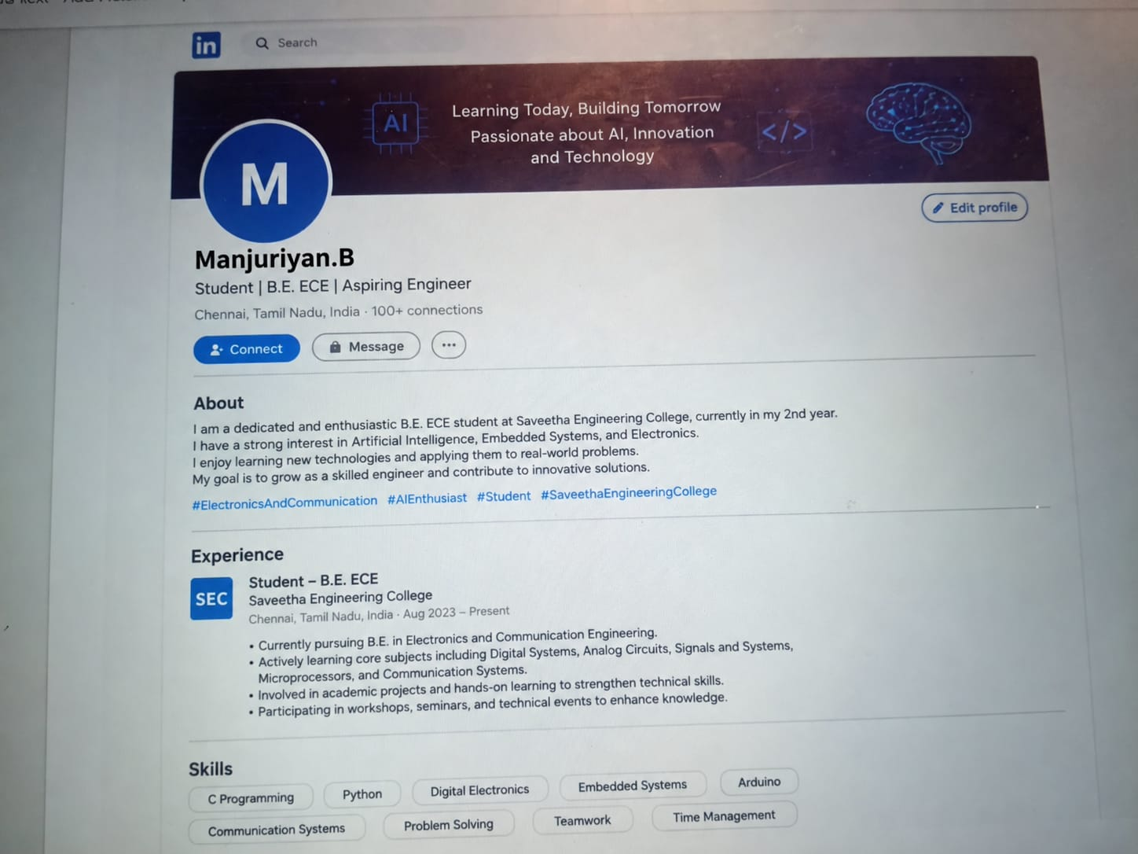

OUTPUT
A simple and professional LinkedIn profile page was successfully
created. The profile contains a professional headline, About section,
educational details, experience/projects, and relevant technical skills
related to Artificial Intelligence and its Applications. The profile was
reviewed and made ready for professional networking and sharing.
RESULT
A simple and professional LinkedIn profile was successfully created
with essential sections such as Profile Photo, Headline, About,
Education, Experience/Projects, and Skills. AI tools were alsounderstood as useful assistants for preparing professional
descriptions and improving the presentation of profile information.

CONCLUSION
Thus, a professional LinkedIn profile was created successfully. The
experiment demonstrated the importance of maintaining a
professional online presence and showed how Artificial Intelligence
tools can assist in creating, improving, and organizing professional
profile content. A well-maintained profile can help students
showcase their AI-related knowledge, projects, skills, and
achievements while conn

